PACE AEROSPACE BEARINGS LTD
CAPACITY LIST
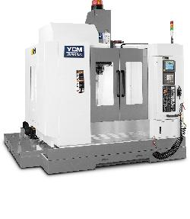
CNC MILLING

YCM FX350 5 AXIS MACHINING CENTRE WITH FULL 5 AXIS SIMILTANIOUS CONTOURING CAPABILITY

TRAVEL: 700mm X 520mm X 480mm- -- TABLE DIA. 350mm

CONTROL : HEIDENHAIN i530TNC

SPINDLE : 12,000 RPM

YCM XV-1020-AH VERTICAL MACHINING CENTRE

WITH 5 AXIS MACHINING CAPABILITY

TRAVEL: 1020mm X 520mm X 540mm- -- plus 5 Axis Dextron table

CONTROL : HEIDENHAIN i530TNC

SPINDLE : 10,000 RPM

BRIDGEPORT VMC 1000 VERTICAL MACHINING CENTRE

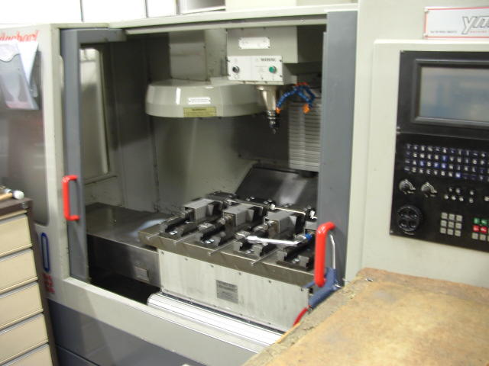
TRAVEL: 1020mm X 600mm X 600mm

CONTROL : HEIDENHAIN TNC 430

SPINDLE : 12,000 RPM

BRIDGEPORT VMC 1000 VERTICAL MACHINING CENTRE

TRAVEL: 1020mm X 510mm X 600mm

CONTROL : HEIDENHAIN TNC 429

SPINDLE : 10,000 RPM

CNC MILLING cont.

BRIDGEPORT VMC 800 VERTICAL MACHINING CENTRE

TRAVEL: 820mm X 510mm X 600mm

CONTROL : HEIDENHAIN TNC 410

SPINDLE : 10,000 RPM

WITH 4TH AXIS

BRIDGEPORT VMC 800 VERTICAL MACHINING CENTRE

TRAVEL: 820mm X 510mm X 500mm

CONTROL : HEIDENHAIN TNC 370

SPINDLE : 10,000 RPM

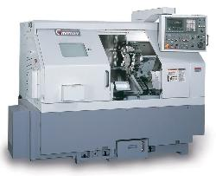
CNC TURNING

GOODWAY GA 2800 LATHE

CAPACITY ;DIA 350mm X 580mm LONG

80mm BAR CAPACITY

CONTROL : FANUC Oi-TC

GOODWAY GA 2800 LATHE

CAPACITY ;DIA 350mm X 580mm LONG

80mm BAR CAPACITY

CONTROL : FANUC Oi-TC

GOODWAY GCL-2BL LATHE

CAPACITY ;DIA 230mm X 625mm LONG

52mm BAR CAPACITY WITH BARFEED

CONTROL : FANUC Oi-TC

ECOCA SJ25HT LATHE

CAPACITY ;DIA 208mm X 460mm LONG

52mm BAR CAPACITY

CONTROL : FANUC 18i-

HARDINGE T42 CONQUEST

CAPACITY ;DIA 255mm X 250mm LONG

42mm BAR CAPACITY WITH BARFEED

CONTROL : FANUC 18T

HARDINGE GT27 CONQUEST SUPER PRECISION

CAPACITY ;DIA 27mm X 200mm LONG

27mm BAR CAPACITY WITH BARFEED

CONTROL : FANUC 18T

CNC TURNING cont.

ECOCA SJ12

CAPACITY ;DIA 355mm X 200mm LONG

52mm BAR CAPACITY

CONTROL : FANUC OT

CNC WIRE ERODING

SODICK A320S

CAPACITY ;TANK 800mm X 600mm

TRAVEL ; X=320mm ,Y=205mm, Z =175mm

CONTROL : FINE SODICK MARK EX EDM

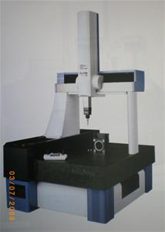
INSPECTION

BATY SHADOWMASTER

15 “ SCREEN

DIGITAL READ OUT

OTHER INSPECTION EQUIPMENT INCLUDES:

EXTERNAL MICROMETERS ; 0 TO 500mm

INTERNAL MICROMETERS ; 0 TO 500mm

SURFACE TABLES, HEIGHT GAUGES, SLIPS ETC.

GEAR CUTTING

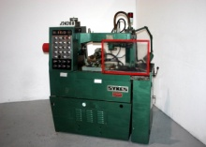

DRUMMOND MAXI-CUT 2A

GEAR SHAPER FOR CUTTING SPUR & HELICAL GEARS

INTERNAL & EXTERNAL

SYKES 10A GEAR & RACK SHAPER

FOR CUTTING LARGER GEARS & PREDOMIANTLY SETUP FOR CUTTING RACKS

MIKRON 102 2 off

FOR HOBBING SMALL GEAR SIZES

HERBERT GEAR SHAPER GRINDER

ALLOWS US TO RE-GRIND THE SHAPER CUTTERS IN HOUSE

MIKRON 121 HOB GRINDER

FOR RE-GRINDING HOB CUTTERS

SAWS
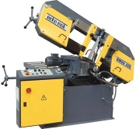

JAESPA W-260

FULLY AUTOMATIC HORZONTAL BANDSAW

MEC BROWN PEDRAZZOLI

275mm CIRCULAR SAW

ASSEMBLY

DEDICATED ASSEMBLY AND PARTS STORAGE AREA

MEZZANINE SETUP WITH ASSEMBLY BENCHES & RACKING TO CREATE A CLEAN AREA FOR ASSEMBLY WORK

POWER PRESS

MARCLO BROACHING PRESS

POWERED HYDRAULIC PRESS WITH FULL PRESSURE CONTROL FOR BROACHING KEYWAYS & PRESSING ASSEMBLIES TOGETHER

PROCESS PARTNERS

SHEETMETAL & WELDING

ALL ASPECTS OF SHEETMETAL WORK UNDERTAKEN INCLUDING FERROUS & NON-FERROUS WELDING

PLATING & POWDER COATING

OUR METAL FINISHERS CAN CARRY OUT MOST SURFACE TREATMENTS

HEAT TREATMENTS

ALL TYPES OF HEAT TREATMENT FROM STRESS RELIEVING TO VACUUM HARDENING & PLASMA NITRIDING

